**PRACTICAL-3**

**AIM: Create user Student feedback form (use textbox, text area, checkbox, radio button, select box etc.)**

<html>

<head>

<title>Registration</title>

<style>

h2 {

background-color: black;

color: white;

border-radius: 30px;

width: 35%;

margin: auto;

margin-top: 40px;

padding: 10px;

}

.main {

width: 30%;

margin: 2em auto;

border: 2px solid black;

padding: 1em;

}

.main input[type="submit"] {

width: 95%;

border: 1px solid black;

padding: .5em;

margin: .5em;

}

.main input[type="password"] {

width: 95%;

border: 1px solid black;

padding: .5em;

margin: .5em;

}

.main input[type="text"],

.main input[type="email"] {

width: 45%;

border: 1px solid black;

padding: .5em;

margin: .5em;

}

</style>

</head>

<body>

<center> <h2> Student Registration </h2> </center>

<div class="main">

<form method="post" action="16(1d).php">

<label for="fname"> FIRST NAME:</label>

<input type="text" name="fname" placeholder="First Name"><br>

<label for="lname"> LAST NAME:</label>

<input type="text" name="lname" placeholder="Last Name"><br>

<label for="email"> EMAIL ID: </label>

<input type="email" name="email" placeholder="Email"><br>

<label for="mobile"> MOBILE NO.:</label>

<input type="text" name="mobile" placeholder="Mobile">

<br>

<br>

</center>

<hr>

<BR>

BRANCH:

<input type="radio" name="branch" value="CE">CE

<input type="radio" name="branch" value="CSE">CSE

<input type="radio" name="branch" value="IT">IT

<input type="radio" name="branch" value="MECHANICAL">MECHANICAL

<input type="radio" name="branch" value="CIVIL">CIVIL<br><br>

<hr>

<br>

Hobbies:

<input type="checkbox" name="hobby[]" value="reading">reading

<input type="checkbox" name="hobby[]" value="singing">singing

<input type="checkbox" name="hobby[ ]" value="traveling">traveling

<input type="checkbox" name="hobby[ ]" value="writing">writing

<input type="checkbox" name="hobby[ ]" value="driving">driving<br><br>

<hr>

<br>

<label for="feedback"> STUDENT FEEDBACK:</label><br>

<textarea name="feedback" id="feedback" cols="57" rows="5" placeholder="write your feedback here"></textarea><br>

<input type="submit" name="submit" value="SUBMIT">

<br>

</form>

</div>

</body>

</html>

**OUTPUT:**

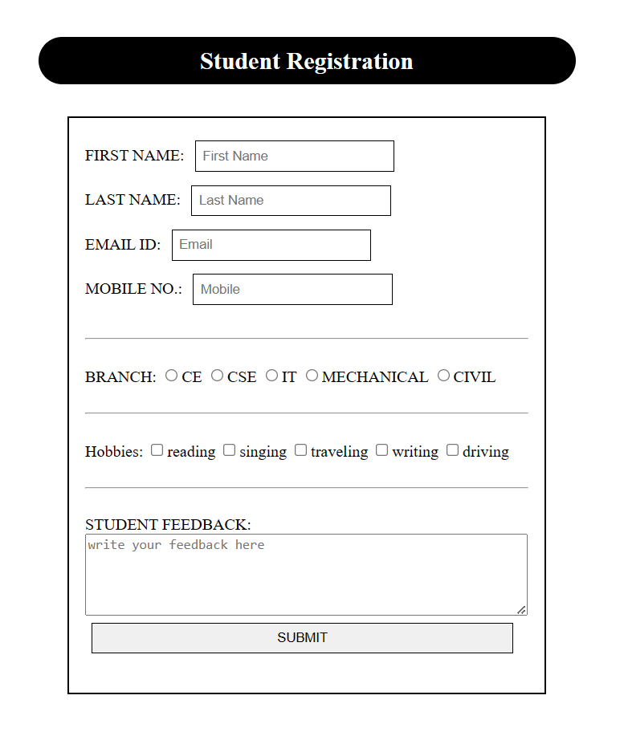

**PRACTICAL-4**

**AIM: Create a web page using frame. Divide the page into two parts with Navigation links on left hand side of page (width=20%) and content page on right hand side of page (width = 80%). On clicking the navigation Links corresponding content must be shown on the right hand side.**

**FRAME PAGE:**

<html>

<head>

<title>PRACTICAL 4</title>

</head>

<frameset cols="20%,*">

<frame src="nav.html" noresize />

<frame name="main_cont" src="http://127.0.0.1:5500/vsitr.html" />

</frameset>

</html>

**NAVIGATION BAR:**

<!DOCTYPE html>

<html lang="en">

<head>

<title>Navigation</title>

<link href="https://fonts.googleapis.com/css?family=Bree+Serif&display=swap" rel="stylesheet">

<style>

body {

margin: 0;

padding: 0;

background-color: #000000;

color: white;

font-size: 2em;

}

header::after {

background: url('https://source.unsplash.com/collection/190727/1600x900')no- repeat center center/cover;

content: "";

position: absolute;

top: 0;

left: 0;

width: 100%;

height: 100%;

z-index: -1;

opacity: 0.3;

}

.navbar {

display: flex;

flex-direction: column;

align-items: flex-start;

list-style-type: none;

padding-left: 20px;

}

.item {

padding: 12px;

}

.item a {

text-decoration: none;

padding: 4px;

color: white;

font-family: 'Bree Serif', serif;

font-size: 20px;

}

.item:hover {

transform: scale(1.3);

transition: 0.5s;

}

.item a:hover {

color: rgb(250, 210, 210);

}

</style>

</head>

<body>

<div class="navigation">

<header>

<nav>

<ul class="navbar">

<li class="item"><a href="vsitr.html" target="main_cont">Practical 1</a></li>

<li class="item"><a href="courses.html" target="main_cont">Practical 2</a></li>

<li class="item"><a href="faculty.html" target="main_cont">Practical 3</a></li>

<li class="item"><a href="Prac_4.html" target="main_cont">Practical 4</a></li>

</ul>

</nav>

</header></div>

</body>

</html>

**OUTPUT:**

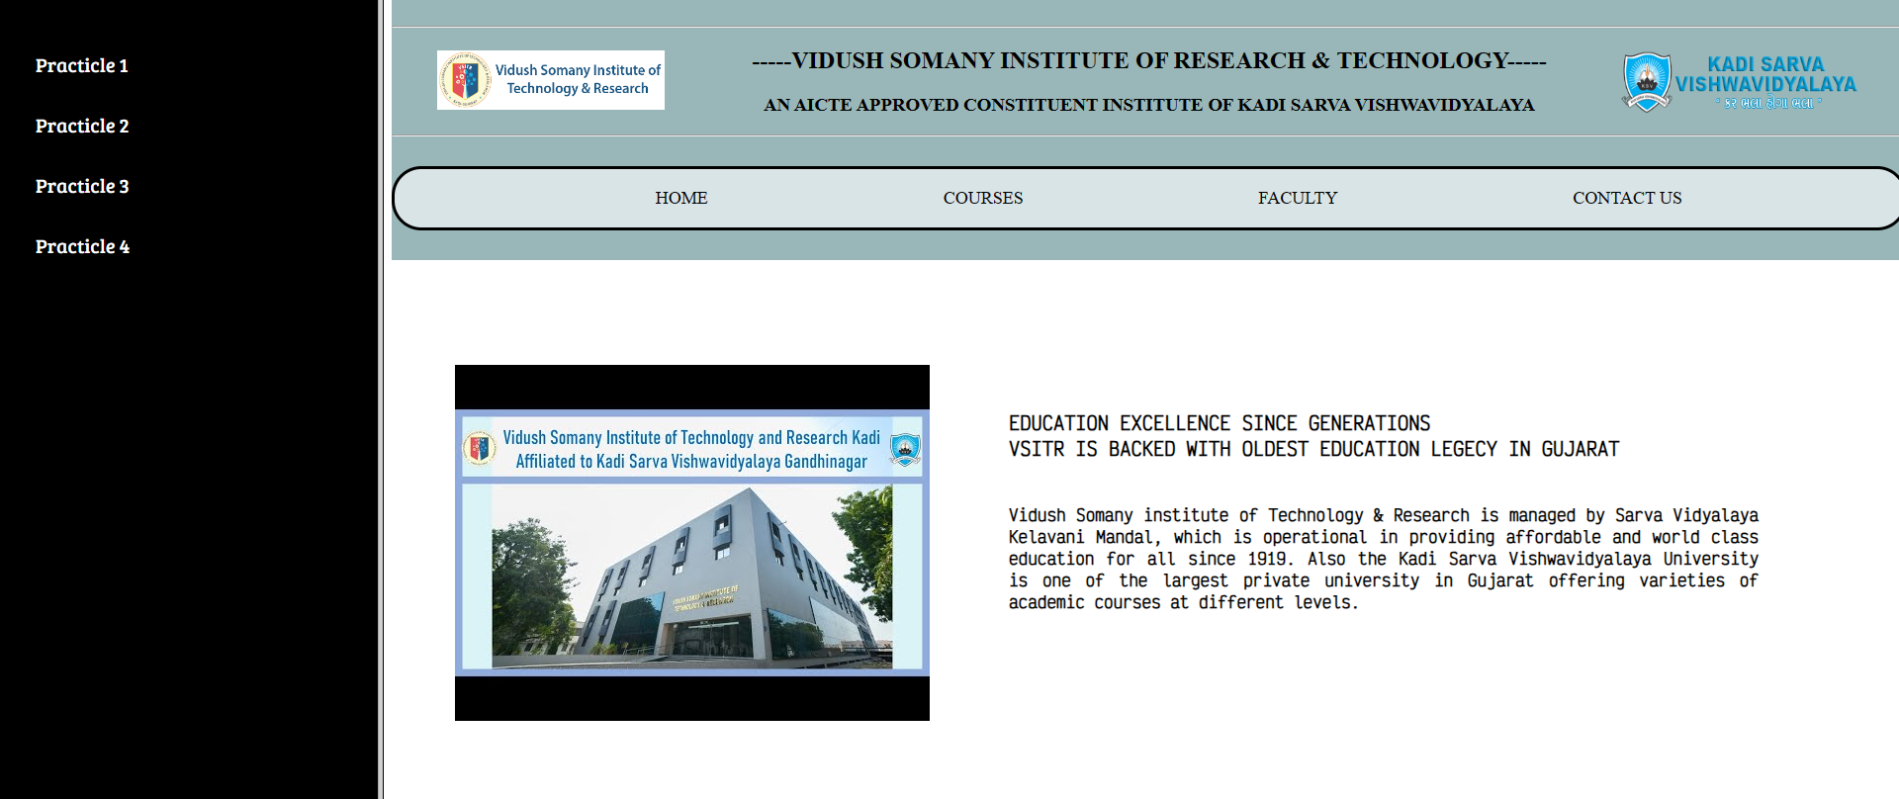

**PRACTICAL-5**

**AIM: Create your resume using HTML tags also experiment with colors, text, link , size and also other tags you studied.**

<!DOCTYPE html>

<html lang="en">

<head>

<meta charset="UTF-8">

<meta name="viewport" content="width=device-width, initial-scale=1.0">

<title>resume</title>

<style>

h1,h2,li,dt{

margin-left: 30px;

}

.pic{

height: 150px;

width: 150px;

display: inline-block;

position: absolute;

left: 250px;

top: 10px;

padding: 1px;

border-radius: 100px;

}

</style>

</head>

<body>

<h1>Janki Patel</h1>

<img src="img3.jpg" alt="picture" class="pic">

<hr><hr><br>

<p>

<h2>Education:</h2><hr>

<ul>

<li>Adarsh high school.</li>

<li>Vidush Somany Institute of Technology & Research.</li>

</ul>

</p>

<br>

<p>

<h2>Interest:</h2><hr>

<ul>

<li>Travelling</li>

<li>Music</li>

<li>Drawing</li><br>

</ul>

</p>

<p>

<h2>Skill:</h2><hr>

<ul>

<li>HTML</li>

<li>CSS</li>

<li>Good speaker</li><br>

</ul>

</p>

<p>

<h2>Experience:</h2><hr>

<dl>

<dt><b>Company 1</b></dt>

<dd>Worked as web developer.</dd>

</dl>

<dl>

<dt><b>Company 2</b></dt>

<dd>Worked as web developer.</dd>

</dl>

<dl>

<dt><b>Company 3</b></dt>

<dd>Worked as web developer.</dd><br>

</dl>

</p>

<p>

<h2>Contact Info:</h2><hr><br>

<b>E-mail:</b> janupatel1812@gmail.com <br><br> <b>Phone No. :</b>9664970910 <br><br>

</p>

</body>

</html>

**OUTPUT:**

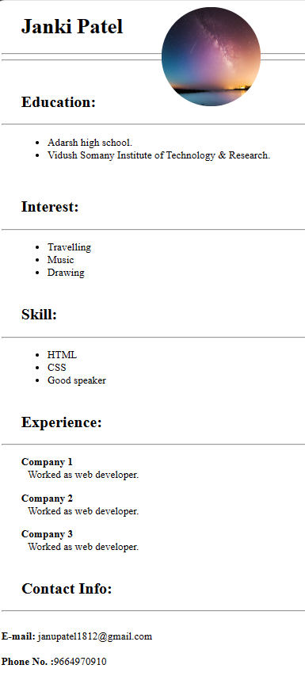

**PRACTICAL-6**

**AIM: Design a web page of your home town with an attractive background color, text color, an Image, font etc. (use internal CSS).**

<!DOCTYPE html>

<html lang="en">

<head>

<meta charset="UTF-8">

<meta name="viewport" content="width=device-width, initial-scale=1.0">

<title>Enchanted Mehsana</title>

<style>

body {

margin: 0;

padding: 0;

font-family: 'Caveat', cursive;

background: linear-gradient(to bottom right, #F76D57, #6438A4);

color: #000000;

}

header {

text-align: center;

padding: 20px 0;

}

.container {

max-width: 900px;

margin: 0 auto;

padding: 30px;

background-color: rgba(255, 255, 255, 0.9);

border-radius: 20px;

box-shadow: 0px 0px 20px rgba(0, 0, 0, 0.3);

}

h1 {

font-size: 3rem;

margin-bottom: 20px;

text-align: center;

}

p {

font-size: 1.2rem;

margin-bottom: 30px;

line-height: 1.6;

}

.city-image {

max-width: 100%;

height: auto;

border-radius: 20px;

box-shadow: 0px 0px 10px rgba(0, 0, 0, 0.2);

display: block;

margin: 0 auto;

}

.highlights {

display: flex;

justify-content: space-between;

align-items: center;

flex-wrap: wrap;

margin-top: 40px;

}

.highlight-card {

background-color: rgba(255, 255, 255, 0.8);

color: #333;

padding: 5px;

border-radius: 15px;

box-shadow: 0px 5px 10px rgba(0, 0, 0, 0.2);

width: calc(33.33% - 20px);

margin-bottom: 20px;

transition: transform 0.2s ease-in-out;

}

/* .highlight-card:hover {

transform: translateY(-5px);

} */

</style>

<link href="https://fonts.googleapis.com/css2?family=Caveat:wght@700&display=swap" rel="stylesheet">

</head>

<body>

<header>

<h1>Discover the Enchantment of Mehsana</h1>

<p>Where Heritage Meets Modernity</p>

</header>

<div class="container">

<h1>Welcome to Mehsana</h1>

<p>Step into a world of wonder in Mehsana, a city that seamlessly blends its rich heritage with a modern spirit.

From historical treasures to artistic delights, every corner tells a story.</p>

<img class="city-image" src="2.jpg" alt="Mehsana City">

<div class="highlights">

<div class="highlight-card">

<h2>Hidden Gems</h2>

<p>Uncover the hidden gems of Mehsana, from quaint streets to serene gardens, and experience the city's

unique charm.</p>

</div>

<div class="highlight-card">

<h2>Artistic Vibes</h2>

<p>Immerse yourself in the artistic vibes of Mehsana. The city is home to galleries, murals, and

creative spaces that will captivate your senses.</p>

</div>

<div class="highlight-card">

<h2>Local Flavors</h2>

<p>Embark on a culinary journey through Mehsana's local flavors. Savory spices and delightful sweets

await your taste buds.</p>

</div>

</div>

</div>

</body>

</html>

**OUTPUT:**

